**Task 4**

Delete a row:

As shown in this screenshot, I have accidently added a few to many rows to my **Customer** table, with one duplicate entry, and one incorrect entry, here’s how I delete them.

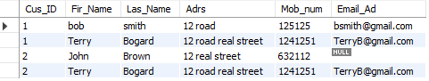

DELETE FROM CUSTOMER

WHERE Cus_ID = '2'

This deletes both customer id 2 entries.



Update a row:

Since both rows in my **customer** table are marked as customer id 1, I need to update a row. Here’s how I updated the second rows customer ID.

UPDATE customer

SET CUS_ID = '2'

WHERE Fir_Name='Terry';

Where statement

I want to find a sale that tod made, to do this I used a select statement with a where condition, as seen here, it helped me narrow down the sale to only those logged sold by tod.

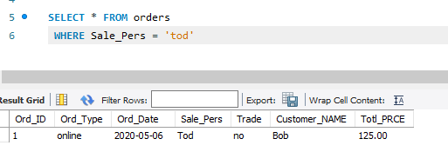

Insert an FK value on referencing table.

ALTER TABLE `dwd504`.`categorys`

DROP INDEX `Cat_Name` ,

ADD INDEX `Cat_Name` (`Cat_Name` ASC) VISIBLE;

;

Join

INNER JOIN customer ON Fir_Name = Las_Name;

There was an error joining, and it would not work.